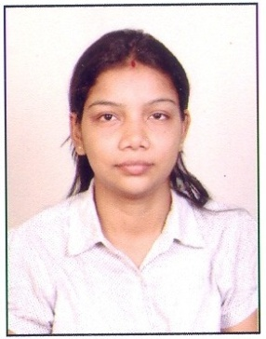
Resume

Chitra Rana
M. Sc (Zoology), B. Ed, CTET

Email: rana.chitra@gmail.com
Tel : +91-9582563356

Profile summary
Looking for resuming part time job.

- Hold Bachelor degree in Education and Masters degree in Zoology.
- Has experience in teaching students of class 6th to 10th with core subject of biology.
- Self initiating and enthusiastic and promote children for their both academic and personal growth.
- Dedicated and self disciplined and provoke the students to inculcate a lifelong love of knowledge.
- Experienced in use of the Internet and technologies around, have written blogs and actively participated in discussions.

Academic profile

Course | Name of the University/Board | College/School | Passing year | Percentage
B.Ed. | CCS University Meerut | NREC, Khurja | 2011 | 72.6%
M.Sc.(Zoology) | CCS University Meerut | Meerut College, Meerut | 2009 | 64%
B.Sc.(Biology) | CCS University Meerut | Meerut College, Meerut | 2007 | 56%
Intermediate | CBSE | Meerut Public girls School, Meerut | 2004 | 59%
High School | CBSE | St. Andrews Public School, Agra | 2002 | 70%

Additional Qualification

- 3 year of N.C.C training (2007) 70 U.P Battalion, Meerut(UP)
- Successfully completed training in areas of teaching methods and strategies during B.Ed.
- Completed training of Scout Guide during B.Ed.

Computer Skills:
Basic computer operating knowledge
MS Word, power point
Use of internet
HTML

Employment
Children’s Academy
3 months experience of teaching (Science for class 6th to 10th.)

Next Gen paper solutions Kleeto)
One year experience of sales
My role there was:
- Make calls to leadership/management cadre of different companies, build and maintain excellent relationships with clients.
- Fixing appointments and scheduling meetings for sales team of Kleeto, Key accounts management.
- Sending communication via Emails and calls and setting calendars for various meetings.
- Sending reports on daily as well as monthly basis for status through mails to Manager.
- Solving queries of clients over mails.

Indiastudychannel.com
Diamond level member
I write articles, participates in forum and have earned creative badge for self.

Personal Details-
- DOB : 01/08/1987
- Nationality : Indian
- Marital Status : Married
- Sex : Female
- Languages : Proficient in English and Hindi
- Hobbies : Writing, Painting and Sketching
- Address : 630, second floor, sector 23
Gurgaon, Haryana

